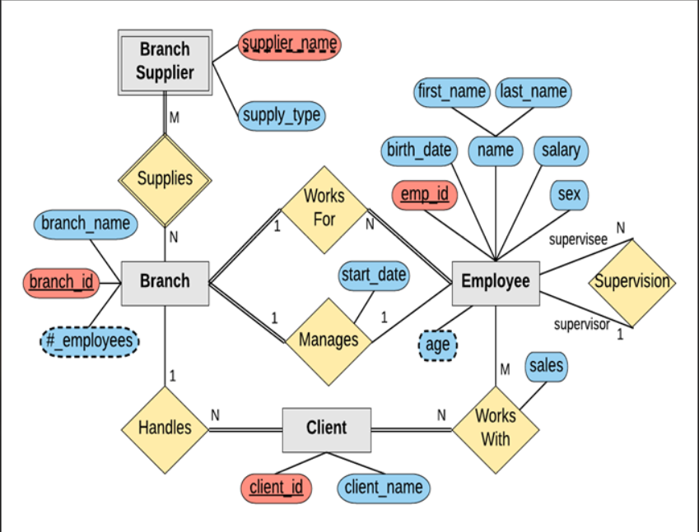

**Branch**(branch_name, branch_id, #_employees, mgr_id**,** start_date)

**Client**(client_id, client_name, Branch_id)

**Employee**(emp_id, birth_date, first_name, last_name, salary, sex, age, super_id**,** Branch_id**)**

**Branch_Supplier**(supplier_name, supply_type, Branch_id**)**

**Works_with**(Client_id, emp_id**,** sales)